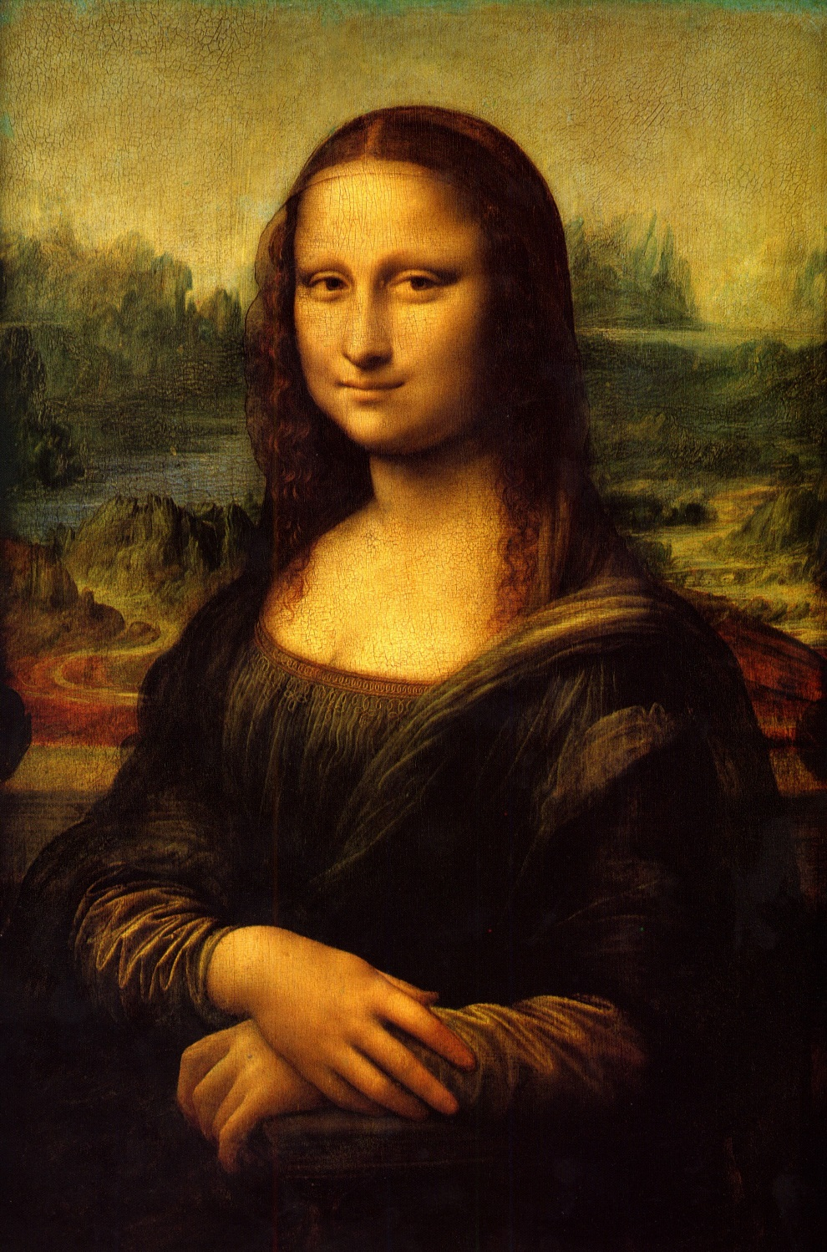

David Houston

EE 225 Lab 4

Bruce Barnes

The Art of Sampling

# Abstract

This lab takes and analyzes the technique of the sampling theorem and the various challenges which encompass it, along with expediting our knowledge of the generation of common sequences. We found the reason and subsequently, the outcome of Aliasing distortion from sampling as well as a way to make sure it doesn’t happen. In all this lab solidified the concepts and drove home the concepts.

# Introduction

The following processes were performed via MATLAB in order to solidify the concepts of common sequences and how the change of sampling rates effects the overall output of the system.

# Procedure

## Generation of Common Sequences

To first analyze the generation of common sequences it was suggested to first construct them and then analyze the response of those functions in the time domain. The following figures are a result of the MATLAB code in Appendix A.

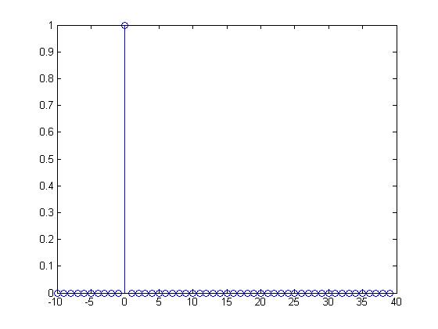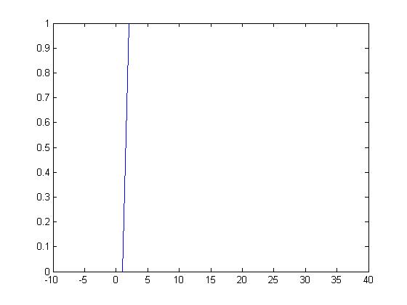

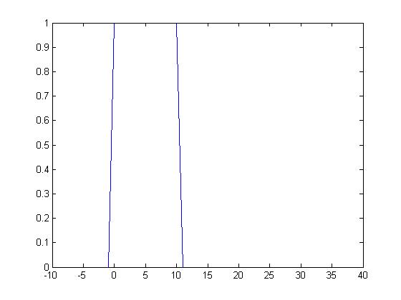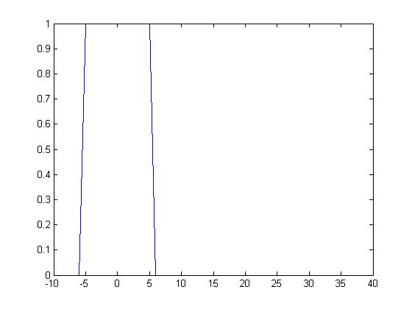

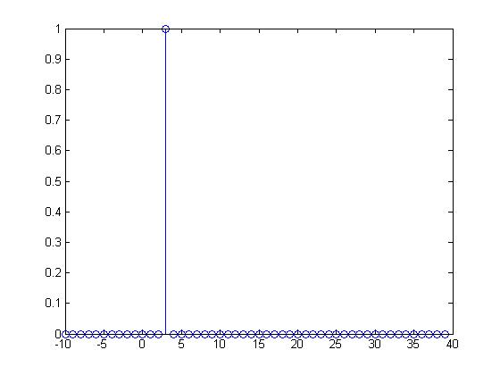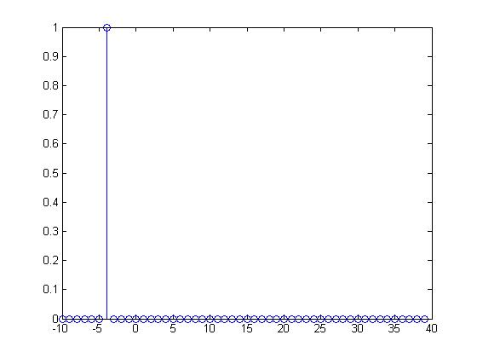

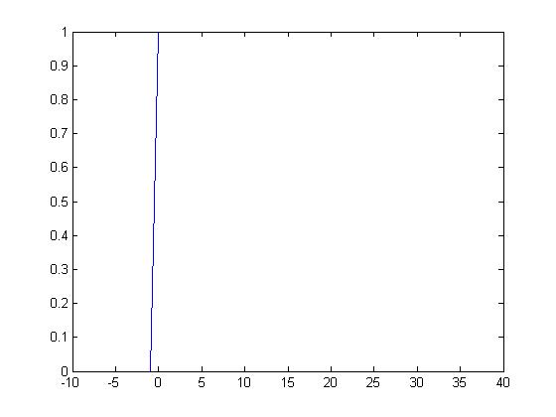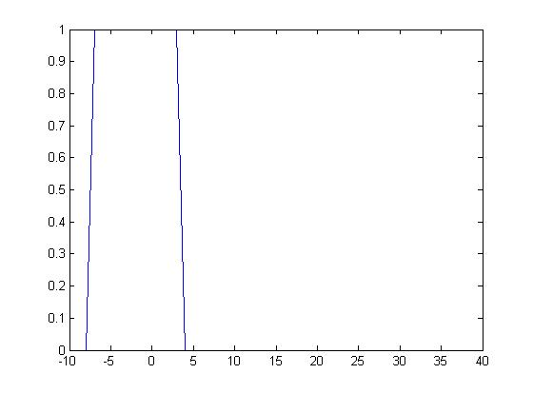

As a result of the process it has become quite clear to us that the generation of the functions is quite easy with the use of **for** loops and **if** statements.

## Sampling Theorem

The sampling theorem takes into account the task of converting analog signals into digital signals. In order to accurately replicate a wave in a digital value sense, the sampling rate needs to be at or above the Nyquist limit (i.e. >2Fm). In the program in Appendix B, it is clearly illustrated the effects Aliasing (sampling distortion) can have on a signal.

Assuming we a have continuous time signal (given below) we can then judge how the sampling rate effects the actual waveform.

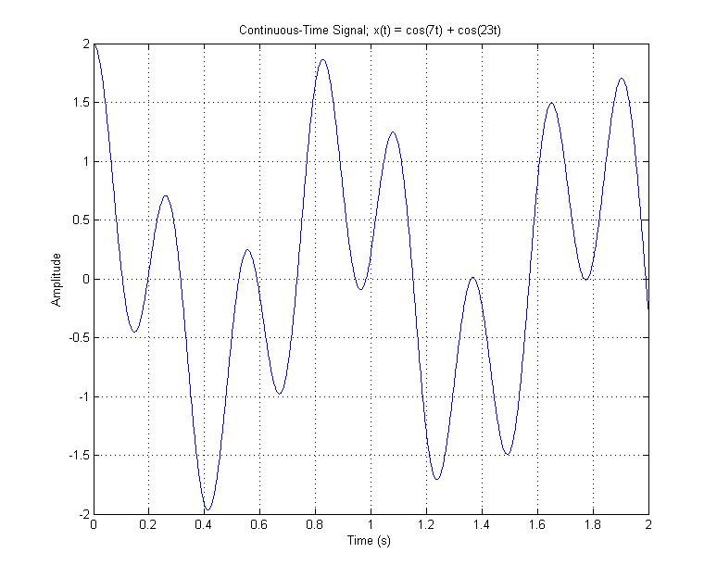

With a sampling frequency of 20 Hz it can be seen that the wave is almost completely replicated

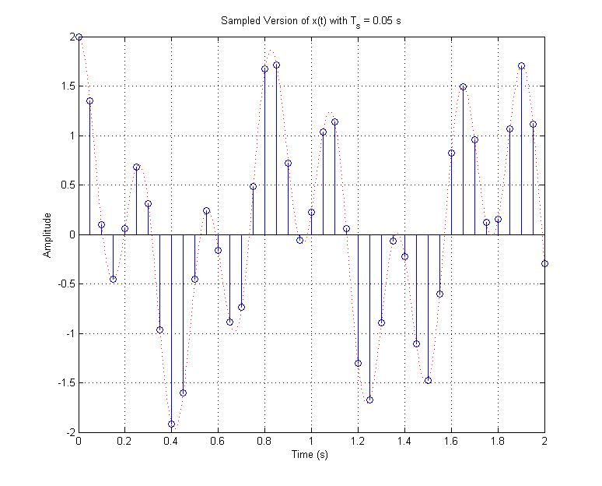

However, as we go to a smaller sampling frequency of 10 Hz, we can see that while the wave shape is still persevered in its general form, it is not quite as accurate.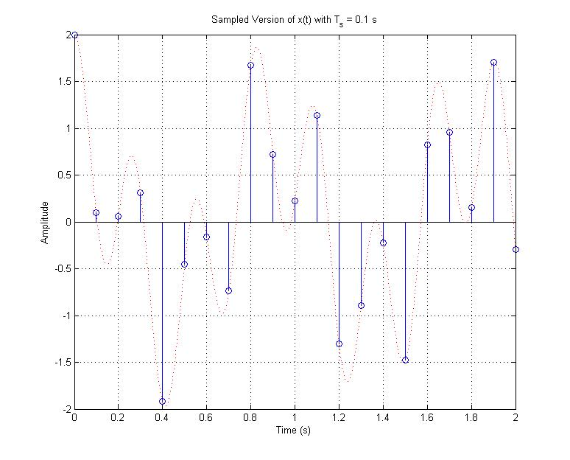

Now if we move to an even smaller sampling frequency of 5 Hz, we can begin to see the effects of aliasing. This is because the max frequency of the system is 3.66 Hz. Thusly, the sampling frequency needs to be at least twice that which 7.32 Hz is. This is the minimum frequency at which aliasing can be avoided. As it can be seen from the following graph the sampled points represent two possible wave shapes with relative frequency components, not just one.

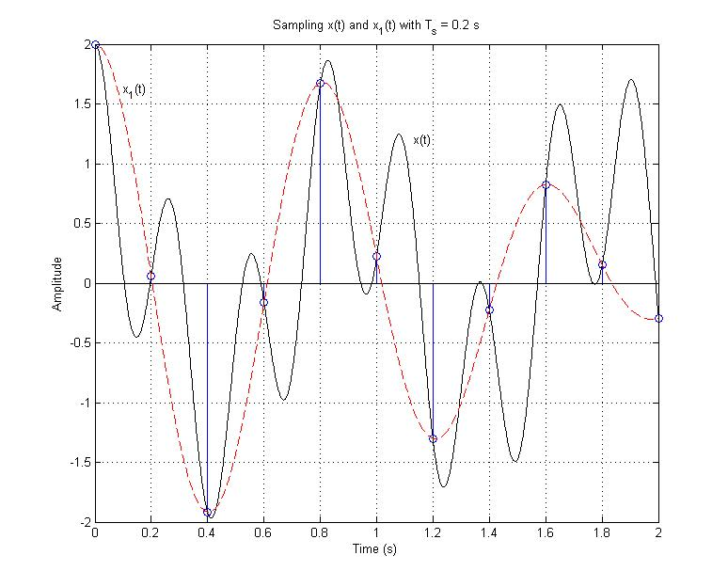

# Conclusion

This lab helped us identify the various ways to construct common sequence functions as well as recognize the problems with Aliasing and being below the Nyquist limit. Based on these assumptions we were able to conclude that these procedures are key to understanding signal theory and communication theory. We need to be able to understand what we are getting as a waveform in order to correctly sample and glean information from the wave.

# Appendix A

clear all

format shorte

n = [-10:1:39];

x1a = zeros(1,50);

x1b = zeros(1,50);

x1c = zeros(1,50);

for k = 1:50

if(n(k) == 0)

x1a(k) = 1;

end

if(n(k) == 3)

x1b(k) = 1;

end

if(n(k) == -4)

x1c(k) = 1;

end

end

figure(1);

stem(n,x1a);

figure(2)

stem(n,x1b);

figure(3)

stem(n,x1c);

x2a = zeros(1,50);

x2b = zeros(1,50);

for k = 1:50

if (n(k) >= 0)

x2a(k) = 1;

end

if(n(k) >= 2)

x2b(k) = 1;

end

end

figure(4)

plot(n,x2a);

figure(5)

plot(n,x2b);

x3a = zeros(1,50);

x3b = zeros(1,50);

x3c = zeros(1,50);

for k = 1:50

if((n(k) >= 0) & (n(k) <= 10))

x3a(k) = 1;

end

h(k) = (n(k)+5);

if((h(k) >= 0) & (h(k) <= 10))

x3b(k) = 1;

end

g(k) = (3-n(k));

if((g(k) >= 0) & (g(k) <= 10))

x3c(k) = 1;

end

end

figure(6)

plot(n,x3a)

figure(7)

plot(n,x3b)

figure(8)

plot(n,x3c)

x4 = zeros(1,50);

t = input('input factor of sampling rate: ')

for k = 1:50

if((n(k) >= 8*t) & (n(k) <= (8*t+3)))

x4(k) = 1;

end

end

figure(9)

stem(n,x4)

# Appendix B

%% SAMPLING_01_MAT

% MATLAB example of a continuous-time signal being

% sampled at various

% frequencies, illustrating the problem of aliasing

% caused by sampling

% at too low of a frequency.

% Sampling periods and sampling frequencies to be

% used.

% ws1 = 125.6637, ws2 = 62.8319, ws3 = 31.415

fig_size = [232 84 774 624];

Ts1 = 0.05; Ts2 = 0.1; Ts3 = 0.2;

ws1 = 2*pi/Ts1; ws2 = 2*pi/Ts2; ws3 = 2*pi/Ts3;

% Frequencies for the continous-time signal and the

% time vector.

w1 = 7; w2 = 23;

t = [0:0.005:2];

% Original continuous-time signal is the sum of two   
% cosines, with frequencies of 7 r/s and 23 r/s,

% respectively.

x = cos(w1*t) + cos(w2*t);

figure(1),clf,plot(t,x),grid,xlabel('Time (s)'),ylabel('Amplitude'),...

title('Continuous-Time Signal; x(t) = cos(7t) + cos(23t)'),...

set(gcf,'Position',fig_size)

% Sampling the continuous-time signal with a sampling

% period Ts = 0.05 s.

% The sampled signal is exactly equal to the

% continuous-time signal at the

% sample times, and the samples accurately model the

% original signal in

% the following respect: if you look at the samples

% by themselves and

% wanted to guess what the continuous-time signal

% looks like, you would be

% able to get pretty close. Note that ws1 is

% approximately 5.5*w2.

t1 = [0:Ts1:2];

xs1 = cos(w1*t1) + cos(w2*t1);

figure(2),clf,stem(t1,xs1);grid,hold on,plot(t,x,'r:'),hold off,...

xlabel('Time (s)'),ylabel('Amplitude'),...

title('Sampled Version of x(t) with T_s = 0.05 s'),...

set(gcf,'Position',fig_size)

% Sampling the continuous-time signal with a sampling

% period Ts = 0.1 s.

% The sampled signal is exactly equal to the

% continuous-time signal at the

% sample times. The samples are a less accurate

% representation of the

% original signal than with the smaller Ts (higher

% sampling frequency ws).

% Note that ws2 is approximately 2.7*w2.

t2 = [0:Ts2:2];

xs2 = cos(w1*t2) + cos(w2*t2);

figure(3),clf,stem(t2,xs2);grid,hold on,plot(t,x,'r:'),hold off,...

xlabel('Time (s)'),ylabel('Amplitude'),...

title('Sampled Version of x(t) with T_s = 0.1 s'),...

set(gcf,'Position',fig_size)

% Sampling the continuous-time signal with a sampling

% period Ts = 0.2 s.

% The sampled signal is exactly equal to the

% continuous-time signal at the

% sample times. The samples now are not a good

% representation of the

% original signal at all. Note that ws3 is

% approximately 1.37*w2.

t3 = [0:Ts3:2];

xs3 = cos(w1*t3) + cos(w2*t3);

figure(4),clf,stem(t3,xs3);grid,hold on,plot(t,x,'r:'),hold off,...

xlabel('Time (s)'),ylabel('Amplitude'),...

title('Sampled Version of x(t) with T_s = 0.2 s'),...

set(gcf,'Position',fig_size)

% Since ws3 < 2*w2, the Nyquist Sampling Theorem is

% violated, and x(t)

% could not be recovered from the samples obtained

% with Ts3 using an ideal

% low-pass filter. Aliasing has occurred. The samples

% of the original

% x(t) using a sampling period Ts3 have exactly the

% same values that the

% signal x1(t) = cos(w1*t) + cos((w2-ws3)*t) would

% have when sampled with

% a sampling period Ts3. w2 - w3 = -8.4159 r/s.

w2s3 = w2 - ws3;

x1 = cos(w1*t) + cos(w2s3*t);

figure(5),clf,stem(t3,xs3);grid,hold on,plot(t,x,'k:',t,x1,'r:'),...

hold off,xlabel('Time (s)'),ylabel('Amplitude'),...

title('Sampling x(t) and x_1(t) with T_s = 0.2 s'),...

set(gcf,'Position',fig_size),...

text(1.13,1.2,'x(t)'),text(0.1,1.6,'x_1(t)')

% Computing the first few frequencies in the sampled

% signals.

n = [-1 0 1]; wx = [-w2 -w1 w1 w2];

wx1 = []; wx2 = []; wx3 = [];

for i = 1:length(n)

wx1 = [wx1 (wx + n(i)*ws1)];

wx2 = [wx2 (wx + n(i)*ws2)];

wx3 = [wx3 (wx + n(i)*ws3)];

end

wx1 = sort(wx1); wx2 = sort(wx2); wx3 = sort(wx3);

clear i